Project Design Phase
Solution Architecture

Date | 6 July 2026
Team ID
Project Name | SHOPEZ – E-Commerce Application
Maximum Marks | 4 Marks

Solution Architecture:
The ShopEz Premium E-Commerce Marketplace is developed using the MERN Stack (MongoDB, Express.js, React.js, and Node.js). It provides a secure and efficient platform for online customers and store administrators. The architecture follows a client-server model where the React frontend communicates with the Express/Node.js backend through REST APIs, while MongoDB stores all application data.
Goals
- Provide a fast and secure apparel sales and checkout platform.
- Enable client and store administrator authentication tiers.
- Manage product catalog browsing, temporary shopping bag states, and purchase history tracking.
- Store customer, product inventory, configuration metrics, and transactional order log information securely.
- Build a scalable and responsive fashion retail application.

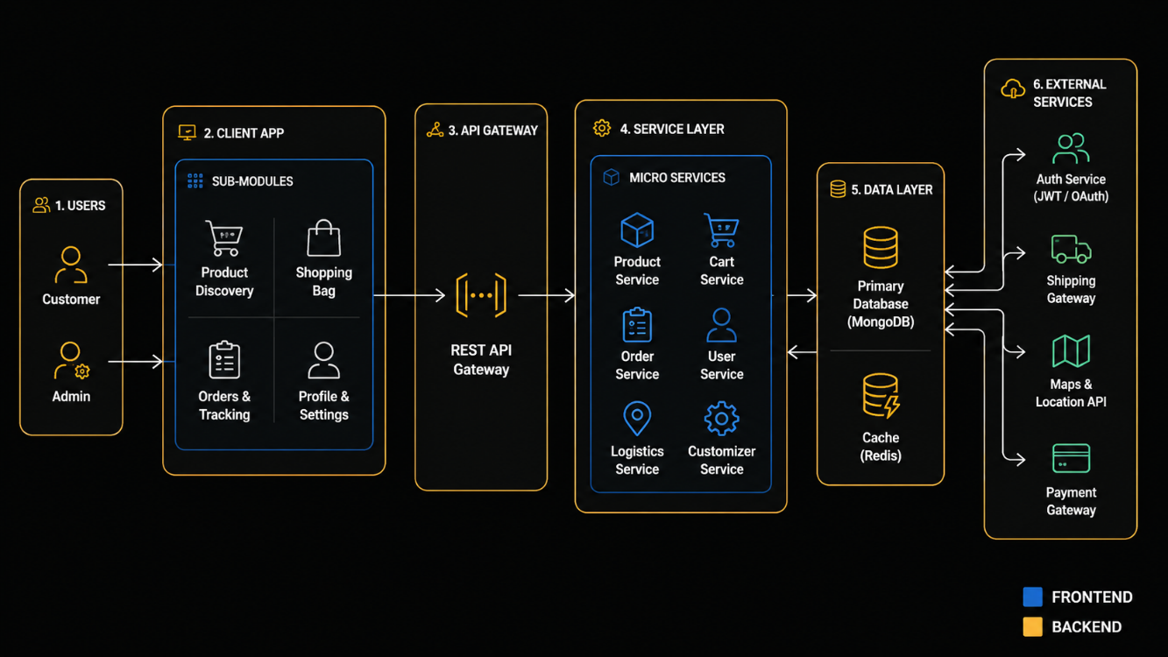
Example - Solution Architecture Diagram:

Figure 1: Solution Architecture of SHOPEZ – E-Commerce Application
Reference: https://aws.amazon.com/blogs/industries/voice-applications-in-clinical-research-powered-by-ai-on-aws-part-1-architecture-and-design-considerations/

